TST company code

Order to stage:

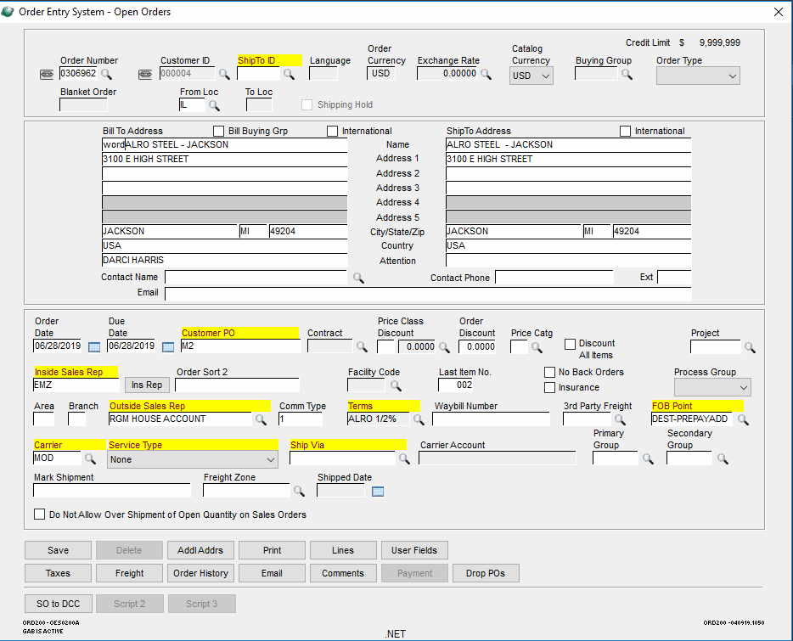

Lines:

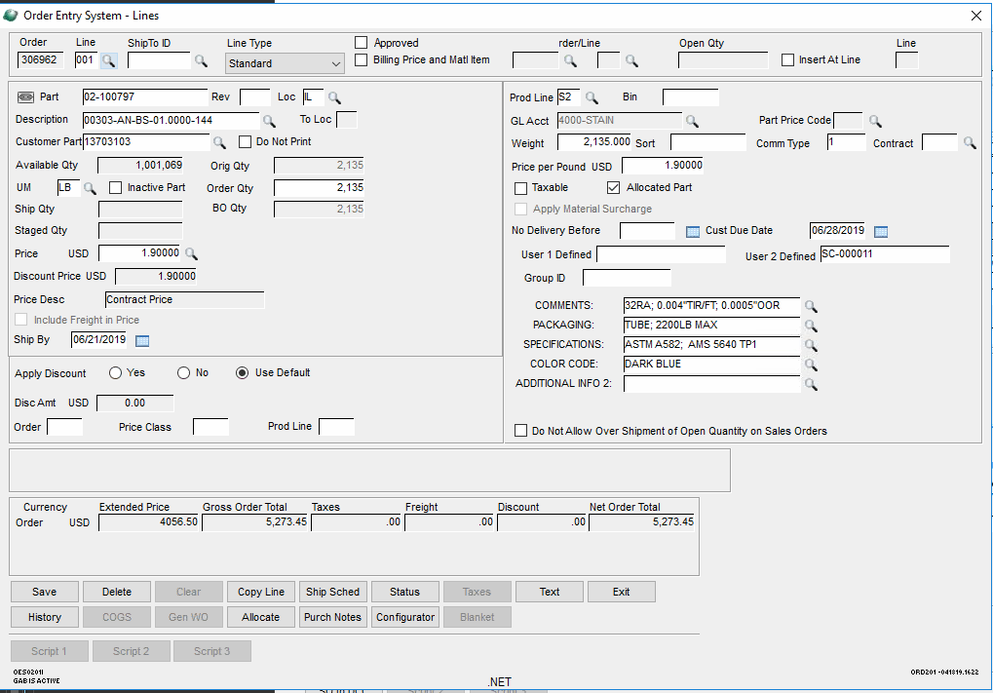

Line 2 is the Surcharge that has user 5 (Additional Info 2): 0010 (reference to the main line which is line 1)

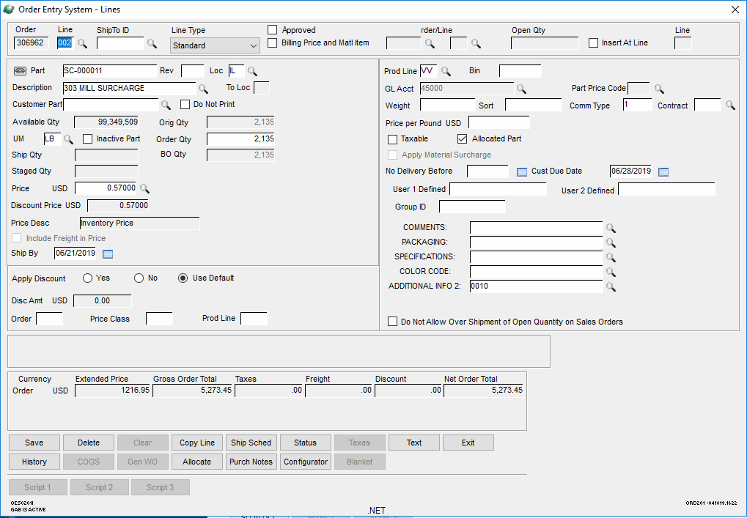

Open GS Mobile

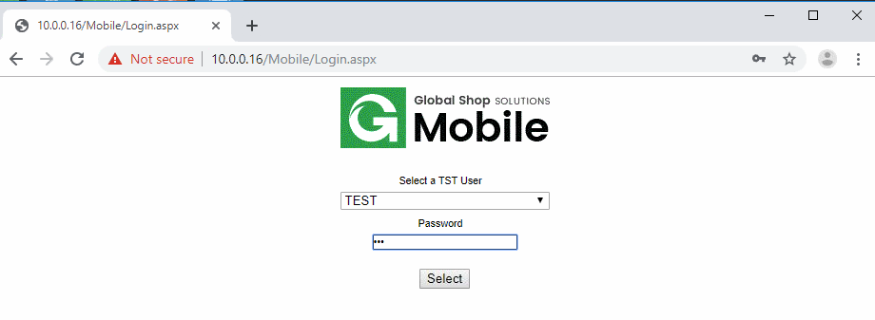

Select Ship by Lot Bin

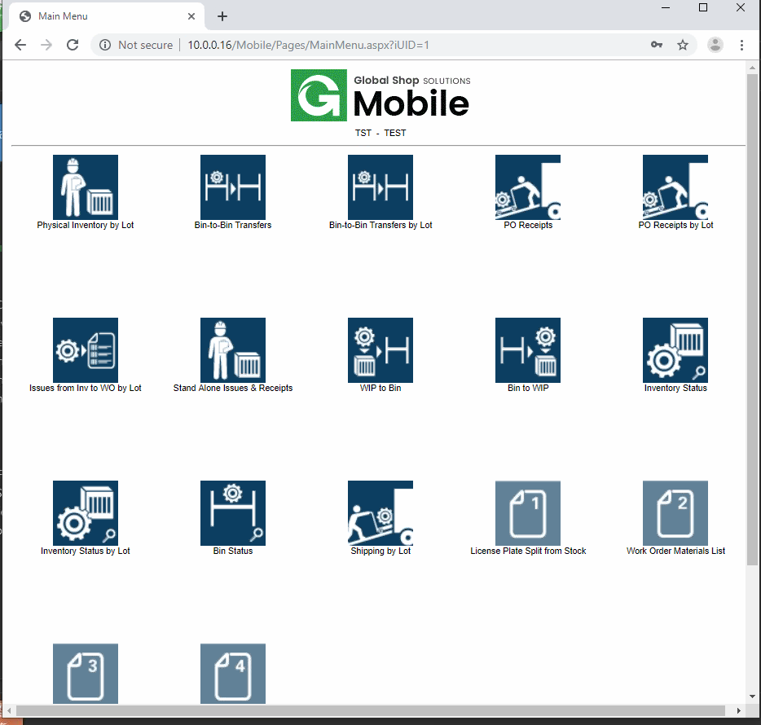

Click Submit to have a new Packing List

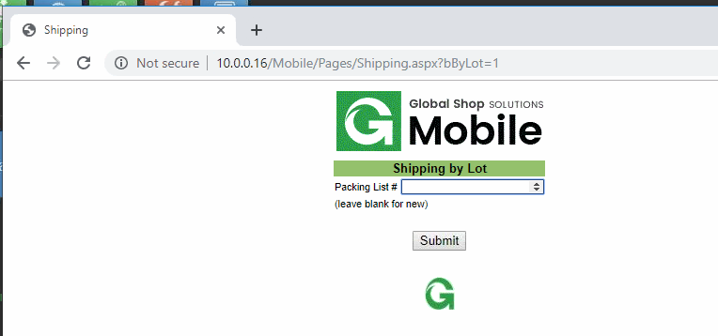

Scan the Order Number and click Submit

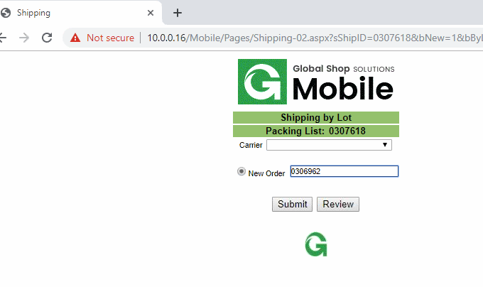

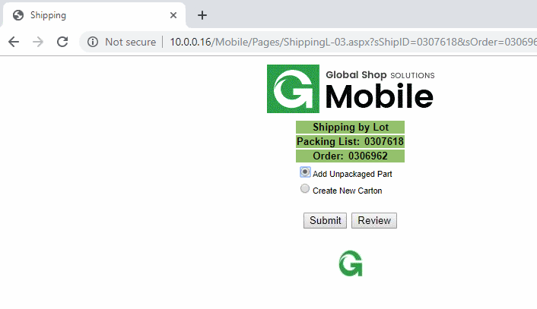

Scan the Lot number of the main line (line 1) and click Submit

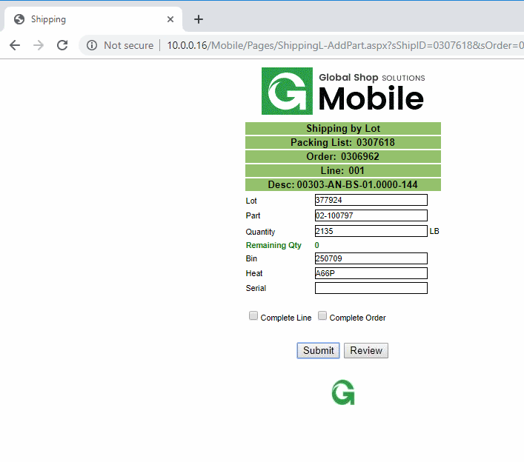

This is the result: SC-000011 (Line 2) is automatically staged after the Line 1

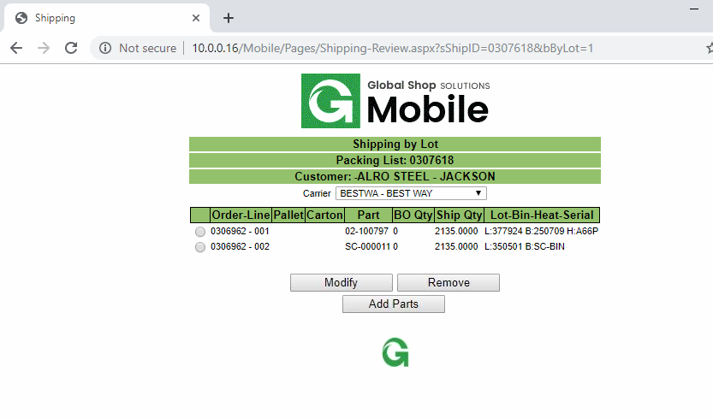

Shipping & Receiving > Transactions > Staging Shipments > Open

